GOVERNMENT POLYTECHNIC COLLEGE
NEDUMANGADU

INTEGRATED COLLEGE PLACEMENT CELL PORTAL

A PROJECT REPORT
Submitted by

Name 1 | 1234567890
Name 2 | 1234567890
Name 3 | 1234567890
Name 4 | 1234567890
Name 5 | 1234567890

to
The State Board of Technical Education (SBTE) in partial fulfilment of the requirements
for the award of

Diploma in Computer Hardware Engineering


Department of Computer Hardware Engineering

2022 – 2025

GOVERNMENT POLYTECHNIC COLLEGE
NEDUMANGADU
DEPARTMENT OF COMPUTER HARDWAREENGINEERING



CERTIFICATE

This is to certify that the project report entitled “INTEGRATED COLLEGE PLACEMENT CELL PORTAL” is a bonafied recored of the Major Project done by SEFIN R R (2201150650), JAYASOORYA J S (2201150636),
NANDHANA A (2201150642), ANANDHU A (2201150625), SARAN C (2201150649), ABHINAND S A (2201150629) under our guidance in partial fulfilment for the award of Diploma in Computer Hardware Engineering from the State Board of Technical Education Kerala during the academic year 2022 – 2025.

Smt. Sheena C Sri. Ratheesh Kumar R
Project Coordinator & Project Guide
Head of Department. Lecturer in Computer
Hardware Engineering Hardware Engineering

Internal Examiner External Examiner

ACKNOWLEDGEMENT

I would also like to extend my heartfelt thanks to the faculty and staff of the Department of Computer Hardware Engineering at Government Polytechnic College, Nedumangad. I am particularly grateful to our College Principal, Mrs. Leena Mary John, whose visionary leadership and commitment to academic excellence have greatly inspired me. Additionally, my sincere appreciation goes to our Head of Department, Mrs. Sheena C, for her unwavering support and guidance throughout this endeavor.

I am deeply grateful to all those who have supported and guided me throughout the development of this project, "Integrated College Placement Cell Portal." First and foremost, I would like to express my sincere gratitude to my project guide, Mr. Ratheesh Kumar R, whose expertise, encouragement, and insightful suggestions have been invaluable in steering this work in the right direction. His constant support not only enriched my learning experience but also played a pivotal role in the successful completion of this project.

Special thanks are due to my colleagues and friends, whose constructive feedback and collaborative spirit helped refine various aspects of this project. Their readine ss to share ideas and assist during challenging phases has been deeply appreciated.

Finally, I am profoundly grateful to my family for their unwavering support and encouragement. Their belief in my abilities and constant motivation have been the driving force behind my academic and personal achievements.

This project stands as a testament to the collective efforts and guidance of everyone mentioned above, and I am truly thankful for all the contributions that made it possible.

SEFIN R R
JAYA SOORYA J S
SARAN C
NANDHANA A
ANANDHU A
ABHINAND S A

ABSTRACT

Placements and alumni engagement form an essential part of academic institutions, directly influencing student growth, career opportunities, and institutional reputation. While placements open doors for students to secure employment and showcase their skills to potential recruiters, alumni networks create long-term connections that support both students and the institution in multiple ways. However, in many colleges, placement activities and alumni data management are still handled manually. This approach is time-consuming, prone to errors, and lacks centralized coordination, which often leads to inefficiencies during recruitment drives and difficulties in maintaining alumni records.
To address these challenges, the Placement & Alumni System Website has been developed as a comprehensive web-based platform. The system aims to automate placement-related tasks, streamline communication among stakeholders, and maintain a structured alumni database. By integrating placement and alumni functionalities into a single solution, the project ensures that institutions can manage these critical activities more effectively while reducing administrative workload.
The proposed system is built using Django (Python) as the backend framework, with SQLite3 serving as the database to store structured information about students, companies, and alumni. The frontend is developed using HTML, CSS, and Bootstrap, ensuring a responsive design that works seamlessly across devices. The application supports role-based access, offering distinct functionalities for different stakeholders such as Admin (Placement Officer), Head of Department (HOD), Faculty, Students, Companies, and Alumni. Each role has been carefully designed to meet its specific responsibilities, ensuring transparency, security, and ease of use.
Key features of the system include secure authentication, student data management, automated eligibility checking for job postings, and company-specific recruitment drives. Students can upload resumes, view eligible job postings, and apply directly through the portal. Companies can register, post job openings, and access lists of candidates that meet their eligibility criteria. Faculty and HODs oversee and verify student data, while administrators maintain complete control over system operations and report generation. Additionally, alumni can register and update their professional details, creating a valuable repository of institutional connections that can be used for future networking and growth.
The Placement & Alumni System Website provides numerous advantages. It minimizes paperwork, ensures accurate and reliable data, and offers real-time access to placement and alumni information. The platform improves communication between students, recruiters, and administrators while maintaining a long-term alumni network. Ultimately, this system empowers educational institutions by offering a modern, scalable, and user-friendly solution that enhances the efficiency of placement processes and fosters meaningful alumni engagement.

INDEX

CHAPTER 1 7
PROJECT BACKGROUND 7
1.1. INTODUCTION 7
Scope 8
1.2. PROJECT OVERVIEW 8
1.3. FUTURE ENHANCEMENTS 9
1.4. SYSTEM STUDY ANALYSIS 9
1.5. SYSTEM SPECIFICATION 10
Software Requirements 10
Hardware Requirements 11
CHAPTER 2 11
2. LITERATURE REVIEW 11
2.1. EXISTING PLACEMENT MANAGEMENT SYSTEMS: 11
Identified Challenges in Existing Systems 12
2.3. GAP ANALYSIS: 12
Identified Gaps in Existing Systems 13
Comparative Analysis 13
2.3. IMPROVED FEATURES IN PROPOSED SYSTEM: 13
CHAPTER 3 14
3. TECHNOLOGIES AND TOOLS USED 14
3.1 Frontend Technologies 14
3.2 Backend Technologies 15
3.3 Database 17
CHAPTER 4 18
4. FEASIBILITY STUDY 18
4.1 Technical Feasibility 18
4.2 Operational Feasibility 19
4.3 Behavioural Feasibility 20
4.4 Legal and Ethical Feasibility 22
CHAPTER 5 24
5. SYSTEM DESIGN 24
5.1 Input Design 24
5.1.1 Objectives of Input Design: 24
5.1.3 Input Integrity Controls: 25
5.2 OUTPUT DESIGN 26
5.2.1 Objectives of Output Design: 26
5.2.2 Types of Outputs: 26
5.3 NORMALIZATION 26
5.3.1 Normal Forms: 27
5.3.2 First Normal Form (1NF): 27
5.3.3 Second Normal Form (2NF): 27
5.3.4 Third Normal Form (3NF): 28
5.4 MODULE DESIGN 28
5.4.1 Admin Module: 28
5.4.2 Placement Cell Module: 29
5.4.4 Company Module: 29
6.1. Basic Components of DFD 30
6.2. Level 0: Context Diagram 30
6.4. Level 2 DFD for Key Modules 31
Actor 32
CHAPTER 8 39
9. CODING AND TESTING 39
8.2. TESTING 40
8.3. SECURITY TESTING 41
8.4. PERFORMANCE TESTING 41
8.5. BACKUP AND RECOVERY MECHANISM 41
CHAPTER 9 43
10. SOFTWARE MAINTENANCE 43
9.1. IMPORTANCE OF SOFTWARE MAINTENANCE 43
9.2. TYPES OF SOFTWARE MAINTENANCE 43
9.8. RISK MANAGEMENT IN MAINTENANCE 44

CHAPTER 1

PROJECT BACKGROUND

INTODUCTION
Manual management of training, placement, and alumni records in many colleges depends heavily on human intervention, which increases the chances of errors and inefficiencies. The primary challenge lies in collecting, searching, and updating student and alumni data. Placement Officers are responsible for handling student profiles, documents, academic records, and coordinating with recruiting companies. They also need to notify eligible students whenever a company posts specific requirements. This process becomes tedious and time-consuming as the number of students and companies increases.
In addition, maintaining alumni records manually is equally challenging, as tracking updates in employment status, designations, or contact information requires repetitive work. The lack of a centralized digital platform often results in missing data, delays in communication, and difficulty in generating accurate reports.
The Placement & Alumni System Website addresses these challenges by offering a robust online platform to manage placement activities and alumni records. With role-based access for Admin, HODs, Faculty, Students, Companies, and Alumni, the system ensures secure data handling and smooth operations. It allows students to create/update profiles, companies to post jobs, and alumni to register and update their professional details. Placement Officers can efficiently manage the process and generate reports, while avoiding the limitations of manual systems.
Purpose
The purpose of the Placement & Alumni System Website is to automate and streamline placement and alumni-related processes in educational institutions. It provides a centralized, secure, and user-friendly platform where:
- Students can register once, update their academic and personal information, upload resumes, and apply for company postings.
- Companies can post job requirements and view eligible student profiles directly.
- Alumni can maintain updated professional records, helping the institution build long-term connections.
- Faculty and HODs can verify data, monitor progress, and mentor students effectively.
- Administrators can oversee the entire system and generate real-time reports.
By reducing manual work, minimizing errors, and saving time, the system ensures that placement activities and alumni engagement are carried out smoothly. It also reduces the workload of placement officers, improves communication, and maintains accurate records for institutional growth.

Scope
The project has a broad scope as it enhances the efficiency, productivity, and reliability of placement and alumni management processes. Unlike manual systems, the Placement & Alumni System Website prevents duplication of work, reduces paperwork, and enables easy retrieval of information. It provides:
- Centralized management of student and alumni records, ensuring up-to-date information at all times.
- Automation of eligibility checking, allowing companies to quickly access suitable candidates.
- Seamless alumni data handling, strengthening institutional networks.
- Role-based access control for Admins, HODs, Faculty, Students, Companies, and Alumni to ensure transparency and security.
- Fast, user-friendly, and reliable operations, enabling quick access to student placement status and alumni details.
The system helps placement officers and institutions overcome difficulties in handling large volumes of student and alumni data. By digitizing and centralizing records, it reduces time, cost, and effort while ensuring accuracy. Ultimately, the project facilitates a modern, scalable, and paperless solution that improves institutional productivity, boosts stakeholder morale, and supports long-term growth.

1.2. PROJECT OVERVIEW
The Placement & Alumni System Website is a web-based platform designed to streamline and automate the management of placement activities and alumni records in educational institutions. Traditional manual processes often involve repetitive tasks such as collecting student data, verifying academic details, maintaining alumni information, and notifying students about job opportunities. These tasks are not only time-consuming but also prone to human error. The proposed system overcomes these challenges by providing a centralized and role-based digital solution.
The system integrates multiple stakeholders into a single platform with distinct functionalities:
- Admin (Placement Officer): Maintains complete control over the portal, manages student and alumni records, verifies data, and generates placement reports.
- Head of Department (HOD): Monitors department-wise student information, verifies academic details, and ensures accuracy of placement records.
- Faculty: Assists in updating student information and provides academic support during the placement process.
- Students: Create and update personal and academic profiles, upload resumes, and apply for company job postings.
- Companies: Register on the portal, post job openings, and view eligible student profiles based on predefined criteria.
- Alumni: Register and update professional details, enabling the institution to maintain a strong alumni database for networking and future growth.
The backend of the system is developed using Python Django, ensuring robust server-side functionality and secure role-based authentication. The database is managed using SQLite3, providing structured storage for student, company, and alumni records. The frontend is built with HTML, CSS, and Bootstrap, ensuring a responsive and user-friendly interface accessible across devices.
The platform supports one-time registration for students and alumni, minimizing redundancy in data entry. Automated eligibility checking ensures that students are notified only about job postings relevant to their academic performance and skills, reducing manual filtering by placement officers. Alumni engagement is seamlessly integrated into the system, allowing institutions to track alumni career growth while fostering long-term connections.
Overall, the Placement & Alumni System Website provides a modern, scalable, and efficient solution to placement and alumni management. It reduces paperwork, saves time, improves communication, and enhances institutional reputation by ensuring smooth and transparent recruitment and alumni engagement processes.

1.3. FUTURE ENHANCEMENTS
The Placement & Alumni System Website is designed to be scalable and adaptable, leaving room for future improvements that can further enhance its effectiveness. In the future, the system can be extended with features such as an automated resume builder that generates professional CVs directly from student profiles, as well as artificial intelligence–based matching to recommend the most suitable job opportunities to students based on their academic performance and skills. Mobile application support for Android and iOS can also be introduced, ensuring that students, companies, and alumni can access the portal anytime and anywhere. Real-time notifications through email or SMS may be integrated to keep users updated about job postings, interview schedules, and alumni events. Additionally, advanced analytics and dashboards can be developed to provide deeper insights into placement statistics, department-wise performance, and alumni career growth. The platform can also incorporate video interview integration to support remote hiring processes and extend its capabilities to foster alumni networking and mentorship opportunities. Over time, the system could be deployed on cloud platforms to enhance scalability and data security, while blockchain-based credential verification may be adopted to ensure authenticity of academic and professional records. These enhancements would make the system more robust, user-friendly, and future-ready, addressing the evolving needs of institutions, students, recruiters, and alumni.

1.4. SYSTEM STUDY ANALYSIS
System analysis is a detailed study of the various operations performed by a system and their relationships within and outside the system. It helps in identifying the problems in the existing system and in determining the requirements for developing an improved system. In simple terms, system analysis can be defined as “figuring out what to make before making it.” It provides a clear understanding of both functional and non-functional requirements, ensuring that the new system effectively solves the challenges of the current process.
System analysis can be categorized into the following five parts:
- System Planning and Investigation – Understanding the objectives of the placement and alumni management process and investigating the shortcomings of the existing manual system.
- Information Gathering – Collecting relevant data from placement officers, students, faculty, companies, and alumni to understand their needs and expectations.
- Applying Analyzing Tools for Structured Analysis – Using analytical methods such as data flow diagrams, process models, and ER diagrams to represent the system clearly.
- Feasibility Study – Evaluating whether the proposed system is technically, economically, and operationally feasible within the given resources.
- Cost/Benefit Analysis – Analyzing the estimated costs of developing and maintaining the system compared with the benefits it provides, such as reduced workload, faster operations, and better accuracy.
Through this structured system study and analysis, the Placement & Alumni System Website ensures a strong foundation for development, minimizing risks and maximizing efficiency in placement and alumni-related activities.
1.4.1. EXISTING SYSTEM
The current placement and alumni management process in colleges is mostly manual, relying on physical records, spreadsheets, and personal communication. Placement officers have to collect and update student data, prepare eligibility lists, and notify students, which becomes time-consuming and error-prone as the number of students increases. Alumni details are also poorly maintained, leading to outdated records and weak engagement. Overall, the existing system lacks automation, is tedious to manage, and creates delays in placement activities.

1.4.2. PROPOSED SYSTEM
The proposed Placement & Alumni System Website replaces the manual process with a centralized, automated, and user-friendly web portal. It provides role-based logins for admins, HODs, faculty, students, companies, and alumni. Students can update profiles and apply for jobs, companies can post vacancies and view eligible candidates, while placement officers can easily manage records and generate reports. The system ensures faster access, accurate data, real-time updates, and secure storage, making placement and alumni management more efficient and reliable compared to the existing manual system.

1.5. SYSTEM SPECIFICATION

Software Requirements
- Frontend: HTML, CSS, Bootstrap
- Backend: Python (Django Framework)
- Database: SQLite3
- Web Server: Django Development Server / Apache (optional)
- Operating System: Windows / Linux

Hardware Requirements
- Processor: Intel i3 or higher
- RAM: Minimum 4 GB
- Hard Disk: 250 GB or above
- Display: Standard resolution (1366x768 or higher)

CHAPTER 2

LITERATURE REVIEW

EXISTING PLACEMENT MANAGEMENT SYSTEMS:
Placement management in many institutions is still handled through manual processes or basic digital tools such as spreadsheets, emails, and offline records. In these systems, placement officers are responsible for collecting student details, verifying eligibility criteria, and preparing lists for company recruitment drives. Communication with students is often done manually through notices, phone calls, or emails, which can lead to delays and missed opportunities.
Some institutions have adopted basic web portals, but these systems are often limited in scope. They may not provide role-based access, automated eligibility checks, or effective data management features. Alumni records, in many cases, are poorly maintained, making it difficult for institutions to track graduates’ career progress or build strong alumni networks.
Overall, existing placement management systems are time-consuming, prone to errors, and lack efficiency. As the number of students and companies increases, the limitations of manual or semi-digital systems become more evident, highlighting the need for a centralized, automated, and scalable solution.
  - EXISTING SYSTEMS AND PROPOSED SOLUTIONS:
Placement management has always been a crucial aspect of higher education, as it directly connects students with career opportunities and employers with skilled graduates. Traditional placement management systems relied heavily on manual processes, where student records, company requirements, and placement activities were handled using registers, spreadsheets, and physical documents. These methods demanded significant administrative effort, were time-consuming, and were prone to human errors such as data duplication, loss of records, and miscommunication between stakeholders [1].
With the advancement of technology, some institutions transitioned to desktop-based applications and local databases for managing placement records. Although these solutions improved data storage and retrieval, they lacked remote accessibility, scalability, real-time updates, and collaborative features [2].
In more recent years, web-based placement portals were introduced, providing centralized data management and online access for students and recruiters. These systems allowed Placement Officers to maintain student profiles, track company requirements, and publish notifications more efficiently. However, existing solutions still faced challenges such as limited role-based access control, lack of mobile compatibility, outdated interfaces, and absence of automated eligibility checks or reporting tools [3].
Some systems attempted to extend functionality by integrating external tools such as resume builders, online test modules, and interview scheduling platforms. While these features added value, they were often fragmented, requiring users to rely on multiple applications instead of a single, seamless platform [4].
Furthermore, most systems lacked predictive analytics, AI-powered recommendations, real-time notifications, and multi-department scalability. Without these capabilities, placement officers struggled to analyze trends, identify eligible candidates efficiently, and ensure smooth communication with recruiters [7].

Identified Challenges in Existing Systems
From comparative analysis, several gaps have been identified in traditional and semi-digital placement management solutions:
- Manual Shortlisting and Eligibility Checks – Academic criteria and eligibility were verified manually, making the process slow and error-prone [2].
- Limited Mobile Accessibility – Many systems were not mobile-friendly, restricting real-time access for students and recruiters [7].
- Complex User Interfaces – Poorly designed and outdated user interfaces discouraged adoption and reduced usability [4].
- Decentralized Data Management – Data was often managed department-wise, preventing centralized access and tracking [3].
- Security Concerns – Older systems lacked robust authentication and access control, exposing sensitive student data to risks [1].
- Lack of Automated Notifications – Most systems relied on manual communication or basic email alerts, causing delays in updates [2].
- Absence of Advanced Analytics – Institutions had limited insights into placement statistics, recruiter participation, and student success trends [7].
- Rigid Customization Options – Many systems could not be adapted or scaled according to institutional needs [4].

2.3. GAP ANALYSIS:
Despite the progress in placement management systems, several shortcomings remain in existing solutions. These limitations hinder efficiency, scalability, and overall user satisfaction. A comparison of the current issues and how the proposed system addresses them is given below.

Identified Gaps in Existing Systems
- Manual Efforts Still Required: Many existing systems relied on manual shortlisting and eligibility checks for students, leading to inefficiencies [2].
- Limited Accessibility: Lack of mobile-friendly interfaces made it difficult for users to access placement information anytime, anywhere [7].
- Poor User Experience: Complicated navigation, outdated designs, and unresponsive interfaces affected user satisfaction [4].
- No Centralized Database: Some systems operated department-wise without integrating all student and company data into a unified, centralized platform [3].
- Minimal Data Security: Older systems lacked secure login features and proper role-based access control, risking data privacy [1].
- Absence of Analytics and Reports: Institutions had no real insights into placement success rates, student performance, or recruiter engagement history [7].
- Inadequate Customization: Existing portals were often rigid and did not allow easy modification based on evolving institutional needs [4].

Comparative Analysis
Feature | Existing Systems | Proposed System
Data Management | Manual / Local Databases | Centralized Web-Based Database
Accessibility | Limited (No mobile support) | Mobile-friendly, responsive UI
Security | Weak access control | Secure login with role-based authentication
User Experience | Complex, outdated UI | Modern, user-friendly, responsive interface
Paperwork Reduction | High dependency on physical records | Fully digitalized process
Recruiter Integration | Limited recruiter access | Direct recruiter-student and recruiter-admin interactions
Analytics | Minimal or none | Advanced placement statistics & performance insights
Customization | Rigid and inflexible | Scalable, adaptable, and customizable features

IMPROVED FEATURES IN PROPOSED SYSTEM:
The proposed Placement & Alumni System Website introduces several enhanced features that overcome the limitations of existing placement management systems. Unlike manual or semi-digital systems, the proposed solution offers centralized data management, allowing administrators, HODs, faculty, students, and companies to access accurate information from a single platform.
The system ensures mobile-friendly and responsive design, enabling users to access placement details anytime and from any device. With secure login and role-based access, sensitive data is protected, and each user can perform their tasks without compromising privacy or integrity. The user interface is designed to be modern and intuitive, simplifying navigation and improving overall user experience compared to older systems with outdated or complex layouts.
Paperwork is significantly reduced as all student profiles, resumes, and alumni records are maintained digitally. Companies can directly post job openings, view eligible candidates, and interact with placement officers, creating better recruiter-student engagement. Furthermore, the system provides advanced analytics and reporting, offering insights into student performance, placement trends, and department-wise statistics, which were largely absent in traditional systems.
Finally, the proposed system is scalable and customizable, allowing institutions to adjust features, add departments, or extend alumni engagement modules as per their evolving requirements. These improved features collectively ensure a faster, more reliable, and user-friendly platform that enhances both placement and alumni management processes.

CHAPTER 3

3. TECHNOLOGIES AND TOOLS USED

3.1 Frontend Technologies
3.1.1 HTML
HTML, or Hypertext Markup Language, is the standard markup language used by web developers to structure and present content on the World Wide Web. Unlike programming languages that execute logical operations, HTML serves as a descriptive language that defines the meaning and organization of different content elements within a web document.
Developers use HTML to specify the nature of various content segments—whether they constitute a heading, a paragraph, a list item, or specially formatted text. This markup is achieved through a system of tags, which are keywords enclosed within angle brackets (< and >). Each tag carries a distinct semantic significance, instructing the web browser on how to interpret and render the enclosed content. The collective use of these tags transforms plain text into a structured, meaningful webpage.
Most HTML directives operate in pairs: an opening tag to initiate the formatting and a closing tag to terminate it. For instance, the <b> tag indicates that the subsequent text should be displayed in a bold typeface. To conclude the bold formatting, the corresponding closing tag </b> is employed. This paired-tag system surrounds and defines the affected text content.
Beyond basic formatting, HTML tags establish the foundational document structure, including headings (<h1> to <h6>), paragraphs (<p>), lists (<ul>, <ol>, <li>), links (<a>), and images (<img>). This structured approach not only dictates visual presentation but also enhances accessibility, search engine optimization, and overall content organization, forming the essential backbone of all modern web development.

3.1.2 CSS
CSS, which stands for Cascading Style Sheets, is the language used to describe the visual presentation and layout of web pages. It works alongside HTML to control how content appears on screen, including aspects such as colours, fonts, spacing, positioning, and responsive design for different devices.
CSS operates on a rule-based system where developers define styles for HTML elements. Each style rule consists of a selector that identifies which HTML elements to style, and a declaration block containing one or more property-value pairs that define the actual styles. This separation of content (HTML) and presentation (CSS) allows for cleaner code, easier maintenance, and greater design flexibility across multiple pages.
The "cascading" aspect refers to how multiple style rules can apply to the same element, with the browser determining which styles take precedence based on specificity, source order, and importance. CSS also supports inheritance, where child elements can inherit styles from their parent elements, creating consistent design patterns throughout a website.
Modern CSS includes powerful features such as Flexbox and Grid layout systems for complex page structures, media queries for responsive design that adapts to different screen sizes, and CSS variables for maintaining consistent design systems. These capabilities enable developers to create visually appealing, accessible, and user-friendly interfaces for web applications like the Placement Management System.
3.1.3 Bootstrap
Bootstrap is a free, open-source frontend framework that provides a comprehensive collection of tools for building responsive, mobile-first websites and web applications. Developed by Twitter engineers Mark Otto and Jacob Thornton, Bootstrap combines HTML, CSS, and JavaScript components to streamline web development while ensuring consistency across different browsers and devices.
The framework addresses common web development challenges, particularly cross-browser compatibility issues, by providing a standardized set of styles and components that work consistently across all major browsers including Chrome, Firefox, Safari, and Internet Explorer. Bootstrap implements a responsive grid system based on a 12-column layout that automatically adapts content to different screen sizes—from desktops and tablets to smartphones—ensuring optimal viewing experiences on all devices.
Bootstrap includes pre-designed components such as navigation bars, buttons, forms, cards, modals, and carousels, along with extensive CSS utilities for spacing, typography, colors, and flexbox layouts. These ready-to-use elements significantly reduce development time while maintaining professional design standards. The framework also features a powerful JavaScript plugin system that enhances functionality without requiring extensive custom coding.
For the Placement Management System, Bootstrap enables the creation of a modern, user-friendly interface with responsive layouts that ensure accessibility for all stakeholders—administrators, faculty, students, and company representatives—regardless of the device they use to access the portal.

3.2 Backend Technologies
3.2.1 Python
Python is a high-level, interpreted programming language renowned for its simplicity, readability, and versatility. Created by Guido van Rossum and first released in 1991, Python emphasizes code readability through its clean syntax and significant use of whitespace, making it accessible to both beginners and experienced developers. As an object-oriented language that supports multiple programming paradigms, Python serves as the backbone for the Placement Management System's backend logic and server-side operations.
The language's extensive standard library and vast ecosystem of third-party packages—particularly the Django web framework—enable rapid development of complex web applications. Python's dynamic typing and automatic memory management streamline the development process, allowing developers to focus on application logic rather than low-level implementation details. Its cross-platform compatibility ensures consistent performance across Windows, Linux, and macOS environments.
For the Placement Management System, Python provides the computational foundation for handling user authentication, database operations, business logic, and AI integration. The language's excellent support for scientific computing and machine learning libraries facilitates the implementation of intelligent features like CGPA extraction and analytics. Python's scalability and maintainability make it ideal for educational institution applications that require long-term evolution and adaptation to changing requirements.
3.2.2 Django Framework
Django is a powerful, high-level Python web framework designed for rapid backend development of secure and scalable web applications. It follows the Model-View-Template (MVT) architectural pattern, providing a structured and efficient way to build the server-side logic of web platforms without relying on external APIs for core functionality. Known for its "batteries-included" approach, Django comes with an extensive set of built-in features that cover common web development needs, allowing developers to focus on application-specific logic rather than reinventing foundational components.
At the heart of Django's backend capabilities is its robust Object-Relational Mapping (ORM)system, which enables developers to interact with databases using Python code instead of raw SQL. This abstraction simplifies database operations, enhances security by preventing SQL injection, and makes the application database-agnostic—allowing seamless switching between SQLite (for development) and PostgreSQL (for production). Django's automatic admin interface provides an instant, customizable backend management panel for handling application data, user accounts, and content.
For authentication and authorization, Django includes a comprehensive user authentication system that supports user registration, login, logout, password management, and permission-based access control—all essential for the Placement Management System's multi-role architecture (Principal, Teacher, Student, Company). The framework's URL dispatcher and view system elegantly handle HTTP request routing and response generation, while its form handling capabilities ensure secure data validation and processing.
Django's built-in security features—including¯¯ protection against cross-site scripting (XSS), cross-site request forgery (CSRF), SQL injection, and clickjacking—make it particularly suitable for educational systems handling sensitive student and placement data. The framework's scalability and maintainability ensure the Placement Management System can efficiently manage institutional growth while supporting complex workflows like student verification, resume processing, job posting, and placement tracking through pure backend logic.

3.3 Database
3.3.1 SQLite3

SQLite3 is a lightweight, serverless, self-contained relational database management system (RDBMS) written in the C programming language. Unlike traditional client-server database systems that require a separate server process, SQLite3 operates as a library within the application itself, reading and writing directly to ordinary disk files. This makes it an ideal choice for development, testing, and deployment scenarios where simplicity, ease of setup, and minimal configuration are priorities.
SQLite3 implements most of the SQL-92 standard and supports common SQL operations including table creation, data insertion, updates, deletions, and complex queries with joins, subqueries, and aggregations. Despite its compact size (typically less than 1MB), it provides full ACID (Atomicity, Consistency, Isolation, Durability) compliance, ensuring reliable transaction processing even in the event of system failures or crashes. The database stores all tables, indexes, triggers, and views in a single cross-platform disk file, simplifying backup and portability.
For the Placement Management System during development and smaller deployments, SQLite3 offers several advantages: zero-configuration setup, no separate server process to administer, transactional integrity, and excellent performance for low to moderate traffic applications. Its seamless integration with Django through the built-in database backend allows rapid prototyping and iteration without complex database infrastructure. The single-file storage approach also simplifies project sharing among development team members and ensures consistent data persistence across different development environments.

CHAPTER 4

4. FEASIBILITY STUDY
A feasibility study represents a systematic and comprehensive analysis conducted to determine the viability, practicality, and potential success of a proposed project or system implementation. This essential evaluation examines multiple critical dimensions including technical capabilities, operational impacts, economic considerations, behavioral acceptance, and legal compliance to ensure that the project can be successfully executed and will deliver the intended benefits and outcomes. For the Placement Management System, this detailed assessment investigates whether transitioning from traditional manual placement processes to an automated digital platform represents a sound and sustainable investment for educational institutions. The primary objectives of this feasibility study encompass evaluating the technical requirements and capabilities necessary for system implementation, analyzing the operational impact and user acceptance patterns, assessing the economic viability and cost-benefit relationships, understanding the behavioral implications and organizational changes required, and ensuring compliance with relevant legal and ethical standards. This multifaceted evaluation serves as a crucial decision-making tool that determines whether the Placement Management System aligns with institutional objectives, available resources, stakeholder needs, and strategic priorities before committing to full-scale development and implementation phases.

4.1 Technical Feasibility
The technical feasibility analysis examines whether the necessary technology infrastructure, development resources, and technical expertise are available and adequate to successfully build, implement, and maintain the proposed Placement Management System. This assessment considers the maturity and stability of required technologies, the availability of necessary hardware and software components, the technical skill sets present within the institution, and the overall technical complexity of the proposed solution. The system architecture leverages well-established technologies including the Django web framework for backend development, SQLite3 and PostgreSQL database management systems for data storage, HTML5, CSS3, and JavaScript for frontend presentation, and Bootstrap framework for responsive interface design. These technologies represent mature, widely-adopted solutions with extensive documentation, strong community support, and proven track records in similar educational and enterprise applications. The hardware requirements for system deployment are modest and align with typical institutional IT infrastructure, necessitating standard web servers with moderate processing capabilities, adequate memory allocation, sufficient storage capacity, and reliable network connectivity. The software stack consists predominantly of open-source components that eliminate licensing costs while providing flexibility for customization and extension.
Technical expertise assessment reveals that the required skill sets including Python programming, web development, database administration, and system management are generally available within educational institution IT departments or can be developed through focused training initiatives. The Django framework's "batteries-included" philosophy significantly reduces development complexity by providing built-in solutions for common web application requirements including user authentication, administrative interfaces, form handling, and security protections. System integration considerations address connectivity with existing institutional systems, third-party service APIs including Google platforms for training and communication, and potential future extensions. Scalability analysis confirms that the system architecture supports both vertical scaling through hardware enhancement and horizontal scaling through distributed deployment patterns to accommodate institutional growth and increasing user loads. Security architecture incorporates multiple layers of protection including secure authentication mechanisms, role-based access controls, data encryption protocols, and comprehensive audit trails that align with industry standards for educational data protection.
Performance considerations include response time optimization, database query efficiency, caching strategies, and load balancing approaches that ensure satisfactory user experience even during peak placement seasons. Maintenance requirements encompass regular software updates, security patching, backup procedures, and performance monitoring that represent manageable ongoing responsibilities for institutional IT staff. Technical risk assessment identifies potential challenges including technology evolution, skill shortages, integration complexities, and security vulnerabilities while proposing appropriate mitigation strategies for each identified risk factor. The development timeline outlines realistic phases for system creation including requirements analysis, design specification, iterative development, comprehensive testing, and gradual deployment that align with academic calendars and institutional planning cycles. Overall technical feasibility determination concludes that the proposed Placement Management System utilizes proven, accessible technologies within reasonable technical capabilities of educational institutions, supported by appropriate risk management and contingency planning approaches.

4.2 Operational Feasibility
Operational feasibility evaluation examines how effectively the proposed Placement Management System can be integrated into existing institutional workflows, processes, and organizational structures while delivering tangible improvements in efficiency, accuracy, and outcomes. This analysis maps current manual placement processes against proposed automated workflows to identify alignment points, disruption areas, and transition requirements. The existing placement ecosystem typically involves fragmented manual procedures including paper-based student registration, spreadsheet tracking of opportunities, email-based communication with companies, physical notice board announcements, and labor-intensive report compilation. These traditional approaches exhibit significant limitations including time consumption, error susceptibility, communication delays, data inconsistency, and limited accessibility that the proposed system directly addresses through digital transformation.
The proposed automated placement workflow streamlines end-to-end processes through online student self-registration, centralized digital profile management, automated eligibility validation, integrated communication channels, real-time status tracking, and comprehensive reporting capabilities. Process mapping demonstrates clear alignment between existing manual procedures and proposed digital workflows with logical transition pathways that minimize disruption while maximizing benefit realization. User training requirements are analyzed across different stakeholder groups including administrators, placement officers, academic faculty, students, and corporate representatives with tailored training approaches developed for each audience based on their specific roles, technical proficiency, and engagement frequency. Training delivery encompasses multiple modalities including in-person workshops, video tutorials, interactive demonstrations, detailed documentation, and ongoing support mechanisms that ensure effective knowledge transfer and skill development.
Support structure design establishes tiered assistance mechanisms including first-level help desk services for common queries, second-level technical support for system issues, and third-level development resources for complex problems or enhancement requests. Maintenance planning outlines routine operational responsibilities including daily monitoring, weekly performance reviews, monthly optimization tasks, quarterly security assessments, and annual comprehensive evaluations that ensure system reliability, security, and continuous improvement. Performance metrics definition establishes key indicators for operational success including system availability, response times, user satisfaction levels, process completion rates, and error frequencies that provide objective measurement of system effectiveness and areas for enhancement.
Change management strategy addresses the human and organizational dimensions of system implementation through structured approaches for communication, involvement, training, support, and reinforcement that facilitate smooth transition and sustainable adoption. Stakeholder impact analysis examines how different user groups will experience changes to their work processes, communication patterns, decision-making approaches, and performance expectations with targeted interventions designed to address concerns and maximize benefits for each constituency. Process improvement quantification estimates time savings, error reduction, quality enhancement, and outcome improvement metrics that demonstrate the operational value proposition of the proposed system. Integration considerations examine how the Placement Management System will interface with existing institutional systems including student information databases, learning management platforms, communication tools, and administrative software to ensure cohesive ecosystem operation.
Resource allocation analysis evaluates personnel requirements, time commitments, and infrastructure needs for successful system operation including ongoing support staff, technical maintenance resources, and user assistance mechanisms. Continuity planning establishes backup procedures, disaster recovery protocols, and business resumption strategies that ensure system availability and data protection even during unexpected disruptions or emergencies. The operational feasibility conclusion determines that the Placement Management System offers substantial improvements over existing manual processes with manageable implementation requirements and significant operational benefits that justify the transition effort and resource investment.

4.3 Behavioural Feasibility
Behavioural feasibility assessment investigates the human and organizational dimensions of system adoption including stakeholder acceptance, change readiness, cultural alignment, and potential resistance factors that influence successful implementation and sustained usage. This analysis examines the perspectives, concerns, expectations, and motivations of different stakeholder groups including institutional leadership, administrative staff, academic faculty, students, and corporate partners to understand how each constituency will perceive and respond to the proposed system. Institutional leadership perspectives typically emphasize strategic benefits including improved placement outcomes, enhanced institutional reputation, operational efficiency gains, data-driven decision support, and competitive positioning within the educational landscape. These decision-makers seek systems that align with institutional priorities, demonstrate clear return on investment, support accreditation requirements, and reflect contemporary educational technology standards.
Administrative staff and placement officers represent critical user groups who will interact extensively with the system in their daily responsibilities. Their concerns often focus on practical considerations including learning curve requirements, workflow disruptions, increased initial workload during transition, job security implications, and technical comfort levels. Their motivations include reduction of repetitive administrative tasks, improved organization of placement activities, enhanced communication capabilities, professional development opportunities, and potential career advancement through technology skill acquisition. Students as primary beneficiaries of the placement system typically exhibit high digital literacy and positive disposition toward technology solutions that simplify administrative processes, increase opportunity access, provide transparent information, and support their career development objectives. Their concerns may include privacy considerations, data security, equitable access, system reliability, and potential technical barriers that could disadvantage certain student groups.
Corporate partners engaged in campus recruitment value systems that streamline their hiring processes, improve candidate quality, reduce administrative burden, enhance communication efficiency, and provide better insights into student capabilities and institutional resources. Their adoption considerations include ease of use, integration with existing HR systems, data accuracy, support responsiveness, and overall value proposition compared to alternative recruitment channels. Change readiness assessment evaluates organizational culture factors, previous technology implementation experiences, leadership support levels, resource availability, and timing considerations that influence institutional capacity to successfully adopt and integrate the new system. Cultural alignment analysis examines how the system's characteristics including transparency, accessibility, efficiency, and data-driven approaches correspond with institutional values, norms, and practices.
Resistance factors identification anticipates potential sources of opposition including comfort with existing processes, fear of technology, concerns about increased workload, perceived threat to job relevance, past negative experiences with technology changes, and general aversion to disruption. Mitigation strategies development creates targeted approaches to address each resistance source through communication, involvement, training, support, and evidence-based demonstration of benefits. Adoption pathway design establishes phased implementation approaches that begin with pilot groups, expand to early adopters, and gradually encompass broader user communities with continuous feedback collection and adjustment throughout the rollout process. Incentive structures consideration examines motivational factors that encourage system use including time savings, performance improvements, recognition mechanisms, integration with evaluation processes, and alignment with professional development objectives.
Communication planning develops comprehensive strategies for informing, engaging, and updating stakeholders throughout the implementation lifecycle using multiple channels, appropriate messaging, and consistent frequency that builds understanding, addresses concerns, and maintains momentum. Training effectiveness evaluation establishes metrics and methods for assessing knowledge acquisition, skill development, confidence building, and behavioral change resulting from training interventions with adjustments based on observed outcomes and feedback. Support system design creates responsive assistance mechanisms including help desk services, peer mentoring programs, online resources, and escalation pathways that provide timely, effective help when users encounter difficulties or uncertainties. Reinforcement mechanisms development identifies approaches for sustaining adoption including performance metrics, success celebration, continuous improvement, integration with workflows, and alignment with institutional priorities that embed system usage into regular organizational practices.
Long-term sustainability analysis examines factors that influence continued system utilization including ongoing value perception, support quality, system evolution, user community development, and alignment with changing institutional needs and external environments. The behavioral feasibility conclusion determines that while some resistance and adjustment challenges are inevitable with any significant organizational change, the Placement Management System offers compelling benefits for all stakeholder groups with manageable adoption requirements through structured change management approaches, comprehensive support systems, and evidence-based demonstration of value that facilitate successful implementation and sustained utilization.

4.4 Legal and Ethical Feasibility
Legal and ethical feasibility examination ensures that the Placement Management System complies with applicable laws, regulations, standards, and ethical principles governing educational technology, data protection, accessibility, and institutional operations. This analysis identifies relevant legal frameworks including data privacy regulations, intellectual property laws, accessibility requirements, contractual obligations, and institutional policies that establish boundaries and requirements for system design, implementation, and operation. Data protection compliance represents a critical consideration given the sensitive nature of student information, academic records, placement outcomes, and corporate engagement data managed within the system. Relevant regulations include institutional data governance policies, educational privacy standards, regional data protection laws, and international frameworks where applicable for institutions with global student populations or corporate partnerships.
Privacy by design principles integration embeds data protection considerations throughout system architecture including data minimization approaches, purpose limitation mechanisms, storage duration policies, access control implementations, and transparency features that inform users about data collection, usage, and protection practices. Consent management establishes clear procedures for obtaining and documenting user agreement for data processing activities with appropriate granularity, revocability, and accessibility that respect individual autonomy and choice. Data security implementation incorporates multiple protective layers including encryption for data at rest and in transit, secure authentication protocols, regular security assessments, vulnerability management processes, and incident response plans that safeguard system integrity and confidentiality.
Intellectual property considerations address ownership rights for system code, user-generated content, institutional materials, and third-party components with appropriate licensing, attribution, and usage agreements that respect copyright protections and enable intended system functionality. Accessibility compliance ensures that the Placement Management System accommodates users with diverse abilities through adherence to established standards including Web Content Accessibility Guidelines that specify requirements for perceivable, operable, understandable, and robust digital interfaces. Implementation approaches include semantic HTML markup, keyboard navigation support, screen reader compatibility, color contrast optimization, text resize capabilities, and alternative content provisions that create inclusive user experiences.
Ethical framework development establishes principles and practices that guide system design and operation including fairness in algorithmic decision-making, transparency in automated processes, accountability for system outcomes, respect for user autonomy, and consideration of societal impacts. Bias mitigation strategies address potential discrimination in automated screening, recommendation, or prioritization functions through regular audit procedures, diverse training data, algorithmic transparency, and human oversight mechanisms that ensure equitable treatment across different student demographics. Transparency implementations provide users with understandable explanations about how system functions operate, what data is used, how decisions are made, and what options exist for review or appeal of automated outcomes.
Contractual compliance examines obligations arising from software licenses, service agreements, partnership arrangements, and institutional policies that establish requirements, limitations, and responsibilities for system operation. Liability considerations address risk allocation for system failures, data breaches, incorrect information, or other potential harms through appropriate disclaimers, limitation of liability provisions, insurance coverage, and incident response planning. Regulatory change monitoring establishes processes for tracking evolving legal and regulatory landscapes affecting educational technology, data protection, accessibility, and institutional operations with adaptation mechanisms that ensure ongoing compliance as requirements evolve.
Ethical review processes incorporate stakeholder perspectives, expert input, and impact assessments that identify potential ethical concerns, evaluate alternative approaches, and establish governance mechanisms for addressing emerging ethical questions throughout system lifecycle. The legal and ethical feasibility conclusion determines that the Placement Management System can be designed and operated in compliance with applicable legal requirements and ethical standards through intentional architecture decisions, comprehensive policy development, regular compliance monitoring, and responsive adaptation to evolving regulatory and ethical landscapes.

CHAPTER 5

5. SYSTEM DESIGN
System design is a feasible solution on how to approach the implementation of the new system. This phase is composed of several steps that provide the procedural details necessary for implementing the system based on the feasibility study. Emphasis is given to how we can better transform the details from the analysis phase to the design stage of the proposed system. The design process goes through logical and physical stages of development. Logical design revises the present input and output specifications, while the physical design maps out the details of the physical system and plans the system implementation.

5.1 Input Design
In an information system, input refers to the raw data that is processed to produce output. During input design, developers must consider input devices such as PCs, MICR, OMR, scanners, and mobile devices. Therefore, the quality of system input determines the quality of system output. Well-designed input forms and screens have the following properties:
- It should serve specific purposes effectively such as storing, recording, and retrieving information.
- It ensures proper completion with accuracy.
- It should be easy to fill and straightforward.
- It should focus on user attention, consistency, and simplicity.
- All these objectives are obtained using knowledge of basic design principles regarding what inputs are needed for the system and how end users respond to different elements of forms and screens.

5.1.1 Objectives of Input Design:
- To design data entry and input procedures
- To reduce input volume
- To design source documents for data capture or devise other data capture methods
- To design input data records, data entry screens, user interface screens, etc.
- To use validation checks and develop effective input controls
- To minimize data entry errors through proper interface design
- To ensure data consistency and integrity
- To provide user-friendly input mechanisms
5.1.2 Data Input Methods:
It is important to design appropriate data input methods to prevent errors while entering data. These methods depend on whether data is entered by users in forms manually and later entered by data entry operators, or data is directly entered by users on PCs. A system should prevent users from making mistakes by:
- Clear form design by leaving enough space for writing legibly
- Clear instructions to fill forms
- Clear form design with intuitive layout
- Reducing keystrokes through dropdowns and auto-completion
- Immediate error feedback with helpful messages
- Using appropriate input controls for different data types
- Providing default values where applicable
- Implementing data validation at point of entry

5.1.3 Input Integrity Controls:
Input integrity controls include several methods to eliminate common input errors by end-users. They also include checks on the value of individual fields, both for format and completeness of all inputs. Audit trails for data entry and other system operations are created using transaction logs which provide a record of all changes introduced in the database to provide security and means of recovery in case of any failure.
Types of Input Controls:
- Field Validation Controls:
  - Data type validation (numeric, text, date)
  - Range validation (minimum/maximum values)
  - Format validation (email, phone, date formats)
  - Required field validation
  - Consistency validation across fields
- Form-Level Controls:
  - Cross-field validation
  - Business rule validation
  - Duplicate entry prevention
  - Referential integrity checks
- Transaction Controls:
  - Audit trails for all data changes
  - User authentication for sensitive operations
  - Transaction rollback capabilities
  - Concurrent access control

5.2 OUTPUT DESIGN
The design of output is one of the most important tasks of any system. During output design, developers identify the type of outputs needed and consider the necessary output controls and prototype report layouts.

5.2.1 Objectives of Output Design:
- To develop output design that serves the intended purpose and eliminates the production of unwanted output.
- To develop output design that meets end users' requirements.
- To deliver the appropriate quantity of output.
- To form the output in appropriate format and direct it to the right person.
- To make the output available on time for making good decisions.
- To present information in a clear, concise, and understandable manner.
- To ensure output is accurate, reliable, and consistent.
- To minimize output processing time and resource consumption.

5.2.2 Types of Outputs:
External Outputs:
Manufacturers create and design external outputs for printers. External outputs enable the system to leave trigger actions on the part of their recipients or confirm actions to their recipients. Some external outputs are designed as turnaround outputs, which are implemented as a form and re-enter the system as input.
Internal Outputs:
Internal outputs are present inside the system and are used by end-users and managers. They support management in decision-making and reporting.
There are three types of reports produced by management information systems:
- Detailed Reports:
They contain present information which has almost no filtering or restriction, generated to assist management planning and control. These reports provide comprehensive information for analysis.
- Summary Reports:
They contain trends and potential problems which are categorized and summarized, generated for managers who do not want details. These reports provide high-level overviews.
- Exception Reports:
They contain exceptions, filtering data to some condition or standard before presenting it to the manager as information. These reports highlight unusual conditions requiring attention.

5.3 NORMALIZATION
Normalization is the process of decomposing attributes in an application, resulting in a set of tables with very simple structure. The purpose of normalization is to make tables as simple as possible. Normalization is carried out in this system for the following reasons:
- To structure the data so that there is no repetition of data.
- To permit simple retrieval of data in response to queries and report requests.
- To simplify the maintenance of data through updates, insertions, and deletions.
- To reduce the need to restructure or reorganize data when new application requirements arise.
- To eliminate data anomalies and ensure data integrity.
- To improve database performance through efficient design.
Primary keys are assigned for this purpose. The primary field in almost all tables helps to ease the search and improve efficiency. The proposed system is designed up to the third normal form (3NF) as it is found most suitable. In second normal form, each row must contain an associated field that describes an attribute of the entry that the table describes. All tables were created according to the rules of normalization.

5.3.1 Normal Forms:
Three normal forms are common: First Normal Form (1NF), Second Normal Form (2NF), and Third Normal Form (3NF), although several others have been defined as part of the theoretical background to relational theory, including Boyce-Codd Normal Form (BCNF), Fourth Normal Form (4NF), and Fifth Normal Form (5NF).
In our Placement Management System, there are 25 tables that satisfy up to the third normal form. The tables consist of atomic values and do not have any functional dependencies that violate normalization rules. However, certain tables are modified to reduce the number of tables and the extent of linking required to retrieve data from these tables. These modifications do not affect normalization but could lead to insertion and deletion anomalies. Hence, intense care has been taken to avoid such situations, and the user interface has been designed keeping this problem in mind.

5.3.2 First Normal Form (1NF):
A relation is in First Normal Form (1NF) if and only if all its attributes are based on a single domain. The objective of normalizing a table is to remove its repeating groups and ensure that all entries of the resulting table have at most a single value. The objective of 1NF is to divide the database into logical units called tables. When each table has been designed, primary keys are assigned to most or all tables.
Characteristics of 1NF:
- Each table cell contains a single value
- Each column has a unique name
- Values in each column are of the same type
- The order of columns and rows does not matter
- No duplicate rows in the table

5.3.3 Second Normal Form (2NF):
A table is said to be in Second Normal Form (2NF) when it is in 1NF and satisfies functional dependency. Functional dependency means that every non-primary attribute is fully dependent on the primary key. The objective of 2NF is to take data that is partially dependent on the primary key and enter that data into another table.
Characteristics of 2NF:
- Must be in 1NF
- All non-key attributes must be fully functionally dependent on the primary key
- No partial dependency on composite primary keys
- Elimination of redundant data

5.3.4 Third Normal Form (3NF):
A table is said to be in 3NF when it is in 2NF and every non-key attribute is functionally dependent only on the primary key. The objective of 3NF is to remove data in a table that is not dependent on the primary key.
Characteristics of 3NF:
- Must be in 2NF
- No transitive dependencies (non-key attributes dependent on other non-key attributes)
- All non-key attributes depend only on the primary key
- Elimination of redundant data through transitive dependency removal

5.4 MODULE DESIGN
The system is divided into four main modules based on user roles, each with specific functionalities:

5.4.1 Admin Module:
The Admin module provides system-wide management capabilities for the Principal or System Administrator.
Key Functions:
- Add, edit, and delete Courses and Departments
- Add and manage Placement Cell members
- View all Students with filtering options
- View all Teachers/Faculty members
- View Placed Student statistics and details
- System configuration and settings
- User role and permission management
- Backup and restore system data
- Generate institutional reports
- Monitor system performance and usage

5.4.2 Placement Cell Module:
The Placement Cell module is designed for Placement Officers and Faculty members responsible for placement activities.
Key Functions:
- Add and manage Student records
- Add and verify Company registrations
- Update Placed Student information
- Search Students based on various criteria
- View Student bio-data and resumes
- Schedule and manage placement drives
- Coordinate interview processes
- Send notifications to students and companies
- Generate placement reports
- Manage training and skill development programs
5.4.3 Student Module:
The Student module provides functionalities for students to manage their placement activities.
Key Functions:
- Update Student Qualifications and academic details
- Upload and manage Resume/CV
- View Companies and available job opportunities
- Apply for jobs and track application status
- View interview schedules and results
- Access training materials and resources
- Update personal and contact information
- View placement statistics and trends
- Receive notifications about placement activities
- Download certificates and documents

5.4.4 Company Module:
The Company module is designed for recruiters and hiring organizations.
Key Functions:
- Search Students based on criteria (CGPA, skills, etc.)
- View students' detailed information and resumes
- Add academic and job requirement information
- View Placed Students history
- Post job openings and requirements
- Schedule campus interviews
- Shortlist candidates for positions
- Provide feedback on candidates
- View placement statistics relevant to their organization
- Manage company profile and contact information

CHAPTER 6
6. DATA FLOW DIAGRAM
A Data Flow Diagram is a graphical representation of the flow of data through a system. It illustrates how data is processed, stored, and transferred between external entities, processes, and data stores. DFDs are essential tools for system analysis and design, providing a clear and logical view of system operations.

6.1. Basic Components of DFD
- Process: Represents a function that transforms incoming data into outgoing data. Shown as a circle or rectangle with rounded corners.
- External Entity: Represents an external source or destination of data (e.g., Student, Company, Admin). Shown as a rectangle.
- Data Flow: Represents the movement of data between processes, entities, and data stores. Shown as an arrow.
- Data Store: Represents a repository of data (e.g., database, file). Shown as two parallel lines or an open-ended rectangle.

6.2. Level 0: Context Diagram
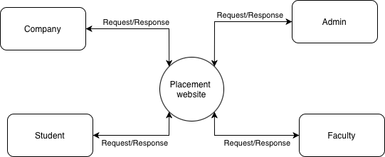

6.4. Level 2 DFD for Key Modules
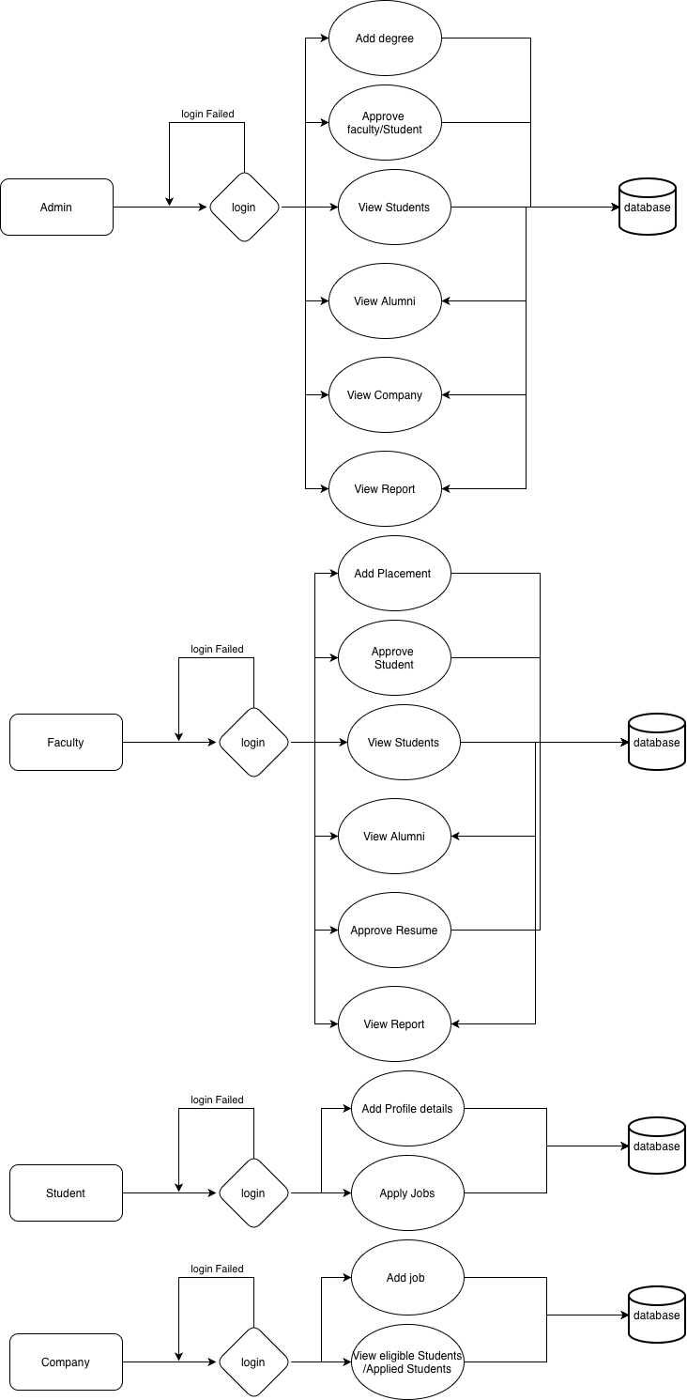

6.1. USE CASE DIAGRAM
A Use Case Diagram illustrates how different users (actors) interact with a system and what functions the system provides. It is mainly used to capture the functional requirements of a system at a high level.
Use Case Diagrams help to:
- Identify system functions and how different roles interact with them.
- Provide an overall view of the system.
- Recognize both internal and external actors.
- Collect requirements influenced by users and outside systems.
The two primary elements of a Use Case Diagram are Actors and Use Cases.

Actor
An represents any entity that interacts with the system. This can be a person, an organization, or another external system. An actor does not belong to the system itself but communicates with it to achieve some goal. Actors are commonly represented using a stick-figure symbol

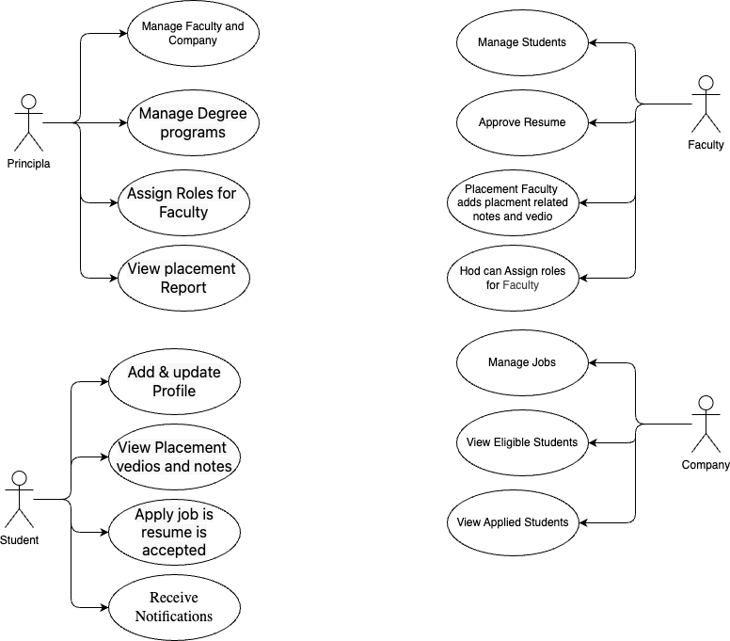

Sequence Diagram:

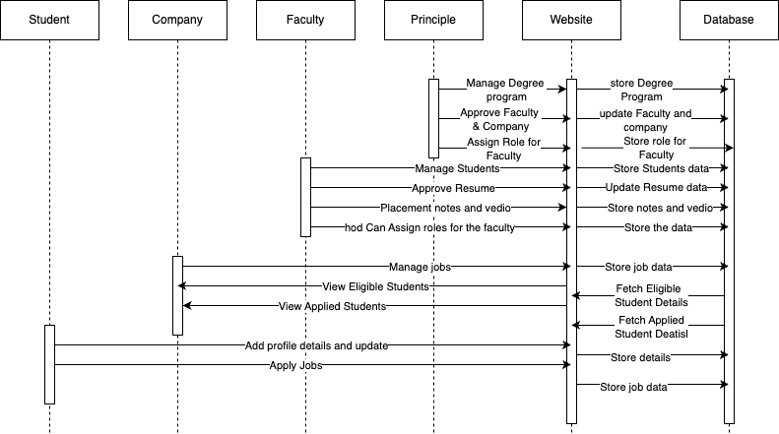

Activity Diagram:

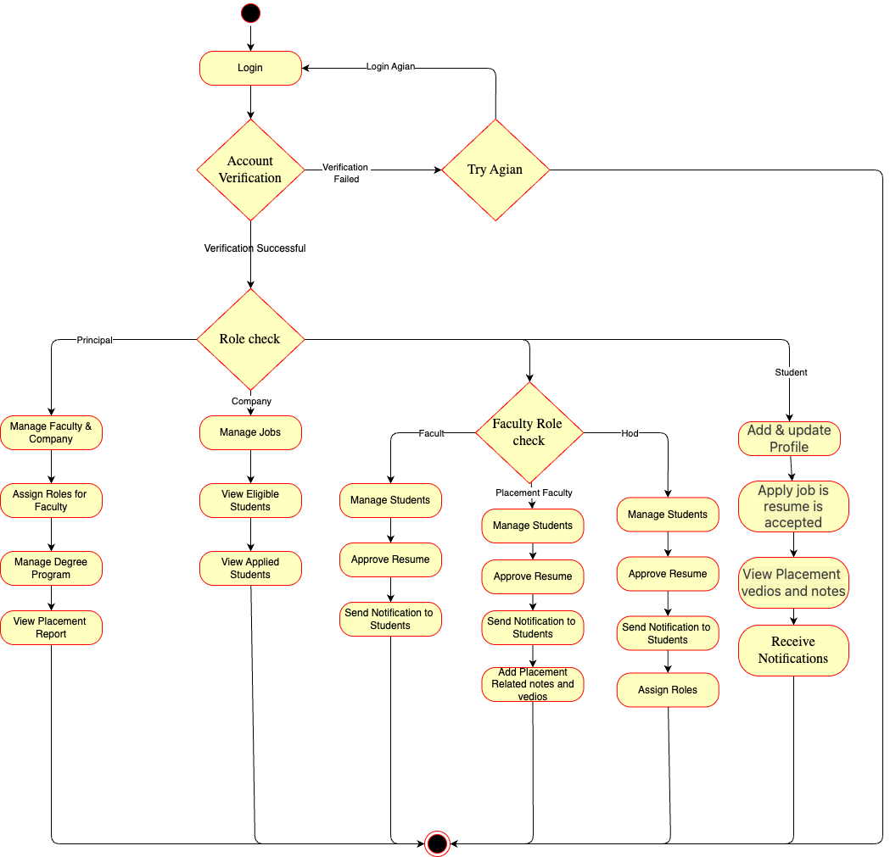

CHAPTER 7
7. DATABASE DESIGN

Database Name :db.sqlite3

Table structure for table User

Field Name | Type | Constraints | Description
id | AutoField | PK | Primary key
username | CharField | UNIQUE | Login username
email | EmailField | UNIQUE | User email
password | CharField | — | Hashed password
first_name | CharField | — | First name
last_name | CharField | — | Last name
is_active | BooleanField | Default True | Account status
is_staff | BooleanField | Default False | Staff access
is_superuser | BooleanField | Default False | Admin access

Table structure for table StudentProfile

Field Name | Type | Constraints | Description
id | AutoField | PK | Primary key
user | OneToOneField(User) | UNIQUE | Linked auth user
roll_number | CharField | UNIQUE | Student roll no
department | CharField | — | Academic department
batch | IntegerField | — | Graduation year
cgpa | DecimalField | 0–10 | Academic score
phone | CharField | — | Contact number
resume | FileField | PDF only | Uploaded resume
is_approved | BooleanField | Default False | Admin approval
created_at | DateTimeField | Auto | Created time
updated_at | DateTimeField | Auto | Updated time

Table structure for table CompanyProfile

Field Name | Type | Constraints | Description
id | AutoField | PK | Primary key
user | OneToOneField(User) | UNIQUE | Recruiter account
company_name | CharField | — | Company name
industry | CharField | — | Business sector
website | URLField | — | Company website
description | TextField | — | Overview
logo | ImageField | JPG/PNG | Company logo
is_approved | BooleanField | Default False | Admin approval
created_at | DateTimeField | Auto | Created
updated_at | DateTimeField | Auto | Updated

Table structure for table JobPosting

Field Name | Type | Constraints | Description
id | AutoField | PK | Primary key
company | ForeignKey(CompanyProfile) | CASCADE | Posting company
title | CharField | — | Job title
description | TextField | — | Job details
requirements | TextField | — | Qualifications
location | CharField | — | Job location
job_type | CharField | — | Full-time / Intern
salary_min | DecimalField | ≤ salary_max | Minimum salary
salary_max | DecimalField | ≥ salary_min | Maximum salary
deadline | DateField | Future date | Apply by
is_active | BooleanField | Default True | Status
created_at | DateTimeField | Auto | Created
updated_at | DateTimeField | Auto | Updated

Table structure for table JobApplication

Field Name | Type | Constraints | Description
id | AutoField | PK | Primary key
student | ForeignKey(StudentProfile) | CASCADE | Applicant
job | ForeignKey(JobPosting) | CASCADE | Target job
status | CharField | — | Applied / Accepted
cover_letter | TextField | — | Optional letter
applied_at | DateTimeField | Auto | Applied time
updated_at | DateTimeField | Auto | Status update

Table structure for table PlacementDetail

Field Name | Type | Constraints | Description
id | AutoField | PK | Primary key
student | ForeignKey(StudentProfile) | PROTECT | Placed student
company_name | CharField | — | Hiring company
position | CharField | — | Job title
package | DecimalField | — | Annual CTC
joining_date | DateField | — | Start date
placement_type | CharField | — | On/Off campus
created_at | DateTimeField | Auto | Created
updated_at | DateTimeField | Auto | Updated

Table structure for table Domain

Field Name | Type | Constraints | Description
id | AutoField | PK | Primary key
name | CharField | — | Domain name
description | TextField | — | Overview
icon | CharField | — | UI icon
color | CharField | — | Theme color
is_active | BooleanField | Default True | Status
created_at | DateTimeField | Auto | Created

Table structure for table Resource

Field Name | Type | Constraints | Description
id | AutoField | PK | Primary key
domain | ForeignKey(Domain) | CASCADE | Parent domain
title | CharField | — | Resource title
description | TextField | — | Details
resource_type | CharField | — | Video / Article
url | URLField | Nullable | External link
file | FileField | Nullable | Uploaded file
order | IntegerField | — | Display order
created_at | DateTimeField | Auto | Created

CHAPTER 8

CODING AND TESTING
This chapter details the implementation phase of the Placement & Alumni System Website, covering the coding standards, architectural patterns, testing methodologies, and quality assurance practices adopted during development.
8.1. CODING
Coding is the process of translating system design specifications into executable source code. The implementation follows structured programming principles, modular design, and industry best practices to ensure maintainability, scalability, and security.

8.1.1. Development Environment
The system was developed in a controlled environment to ensure consistency and compatibility across development, testing, and production stages. The development environment included modern integrated development environments (IDEs) with debugging tools, version control systems for collaborative development, and containerization where applicable to replicate production conditions. The technology stack was carefully selected to balance performance, developer productivity, and future maintainability.

8.1.2. Project Structure and Architecture
The project follows the Model-View-Template (MVT) architectural pattern inherent to Django framework. This separation of concerns ensures that data management, business logic, and presentation layers remain independent and maintainable. The application was organized into discrete Django apps, each representing a functional module of the system. This modular approach facilitates team collaboration, simplifies debugging, and enables independent testing of system components.

8.1.3. Coding Standards and Conventions
Adherence to established coding standards was rigorously maintained throughout the development process. Python code follows PEP 8 conventions for consistency and readability. Meaningful naming conventions were employed for variables, functions, and classes to enhance code comprehensibility. Comprehensive documentation through docstrings and comments was integrated into the development workflow to ensure code maintainability and facilitate knowledge transfer.

8.1.4. Security Considerations in Coding
Security was embedded into the coding process from inception. All user inputs undergo validation and sanitization to prevent injection attacks. Authentication mechanisms implement industry-standard practices including secure password hashing and session management. Authorization checks are implemented at multiple levels to ensure users can only access resources appropriate to their roles. Security headers and protections against common web vulnerabilities were integrated following OWASP guidelines.

8.2. TESTING
Testing ensures that the system functions correctly, meets specified requirements, and delivers a quality user experience. A comprehensive, multi-level testing strategy was implemented to validate the system from individual components through complete integrated operation.

8.2.1. Testing Philosophy and Strategy
The testing approach combines both proactive and reactive methodologies. Test-driven development principles were applied where practical, with tests written before implementation for critical functionality. Continuous testing was integrated into the development workflow, with automated test execution triggered by code changes. The testing strategy prioritizes user-centric validation, ensuring that system behavior aligns with stakeholder expectations and real-world usage patterns.

8.2.2. Levels of Testing

8.2.2.1. Unit Testing
Unit testing focuses on verifying the correctness of individual system components in isolation. Each function, method, and class was tested independently with various input conditions, including edge cases and error scenarios. Mock objects and test doubles were employed to isolate units from dependencies, ensuring that test failures precisely identify problematic components.

8.2.2.2. Integration Testing
Integration testing validates the interactions between different system modules and components. These tests ensure that data flows correctly across interfaces and that integrated components function cohesively. Integration testing addresses interface compatibility, data exchange protocols, and error handling across module boundaries.

8.2.2.3. System Testing
System testing evaluates the complete, integrated system against specified requirements. End-to-end workflows are tested to validate that the system performs correctly in scenarios that mimic real-world usage. System testing includes functional validation, performance assessment, and compatibility verification across different environments.

8.2.2.4. User Acceptance Testing (UAT)
User Acceptance Testing involves system validation by actual stakeholders to ensure the solution meets business needs and user expectations. UAT was conducted with representative users from each stakeholder category, employing realistic scenarios and actual data where appropriate. Feedback from UAT sessions informed iterative refinements to enhance usability and functionality.

8.2.3. Test Coverage and Metrics
Comprehensive test coverage metrics were tracked throughout development to ensure adequate validation of system functionality. Code coverage analysis identified untested code segments, while requirement traceability matrices mapped tests to specific system requirements. These metrics guided testing efforts and provided objective evidence of testing completeness.

8.3. SECURITY TESTING
Security testing systematically evaluates the system's resistance to malicious attacks and unauthorized access. This testing category validates that security controls function as intended and that vulnerabilities are identified and addressed.

8.3.1. Authentication and Authorization Testing
Authentication mechanisms were tested for resistance to credential guessing, session hijacking, and other authentication bypass techniques. Authorization controls were validated to ensure users can access only permitted resources, with particular attention to role-based access boundaries and privilege escalation vulnerabilities.

8.3.2. Vulnerability Assessment
The system was assessed for common web application vulnerabilities including injection flaws, cross-site scripting, insecure direct object references, and security misconfigurations. Automated vulnerability scanning tools complemented manual penetration testing to identify potential security weaknesses.

8.3.3. Data Protection Validation
Data protection measures were tested to ensure sensitive information is adequately safeguarded. This included validation of encryption implementations, assessment of data transmission security, and verification of privacy controls governing data collection, storage, and processing.

8.4. PERFORMANCE TESTING
Performance testing evaluates system behaviour under various load conditions to ensure responsiveness, stability, and scalability meet requirements.

8.4.1. Load Testing
Load testing simulates expected user concurrency to verify system performance under typical operational conditions. Response times, throughput, and resource utilization were measured to identify performance bottlenecks and optimization opportunities.

8.4.2. Stress Testing
Stress testing assesses system behavior under extreme conditions beyond normal operational parameters. These tests identify breaking points, validate error handling under resource constraints, and ensure graceful degradation when system limits are approached.

8.5. BACKUP AND RECOVERY MECHANISM
Robust backup and recovery mechanisms are essential for system resilience and data protection. These mechanisms ensure business continuity in the event of data loss, corruption, or system failure.

8.5.1. Backup Strategy
A comprehensive backup strategy was implemented with multiple backup types and retention periods. Regular automated backups capture system state, with incremental backups minimizing storage requirements while ensuring recovery point objectives can be met.

8.5.2. Recovery Procedures
Documented recovery procedures provide step-by-step guidance for restoring system functionality following disruptions. Recovery time objectives and recovery point objectives were established based on business requirements, with corresponding technical implementations to meet these targets.

8.5.3. Data Integrity Assurance
Data integrity mechanisms verify backup completeness and consistency. Regular restoration tests validate backup reliability, while checksums and validation routines ensure data remains uncorrupted throughout backup, storage, and restoration processes.

CHAPTER 9

SOFTWARE MAINTENANCE
Software maintenance is the process of modifying and updating a software system after delivery to correct faults, improve performance, adapt to changing environments, or enhance functionality. For the Placement & Alumni System Website, maintenance is a critical ongoing activity that ensures the system remains reliable, secure, and aligned with evolving institutional needs.

9.1. IMPORTANCE OF SOFTWARE MAINTENANCE
Maintenance is essential for the long-term viability and usefulness of any software system. It addresses several key objectives:
- System Reliability: Ensures continuous and error-free operation.
- Security: Protects against emerging threats and vulnerabilities.
- Adaptability: Allows the system to evolve with changing requirements and technologies.
- Performance Optimization: Improves efficiency and user experience over time.
- Cost-Effectiveness: Extends the system's lifespan and maximizes return on investment.

9.2. TYPES OF SOFTWARE MAINTENANCE
Software maintenance can be categorized into four distinct types, each addressing different aspects of system evolution:

9.2.1. Corrective Maintenance
Corrective maintenance involves identifying and fixing errors, bugs, and faults discovered during system operation. This type of maintenance is reactive, responding to issues reported by users or identified through system monitoring.
Examples for Placement System:
- Fixing a bug in the job application submission process
- Resolving database connection errors during peak usage
- Correcting calculation errors in eligibility checking algorithms
- Repairing broken links or navigation issues

9.2.2. Adaptive Maintenance
Adaptive maintenance modifies the system to accommodate changes in the external environment, such as new operating systems, updated web browsers, changes in regulatory requirements, or integration with new institutional systems.
Examples for Placement System:
- Updating the system to support new web browser versions
- Adapting to changes in university academic structures or policies
- Modifying data export formats to meet new reporting requirements
- Integrating with new authentication systems or single sign-on solutions

9.2.3. Perfective Maintenance
Perfective maintenance enhances system functionality, improves performance, or modifies features to better meet user needs. This type of maintenance is proactive, driven by user feedback and strategic improvements rather than fixing problems.
Examples for Placement System:
- Adding new search filters for company job listings
- Optimizing database queries to improve response times
- Enhancing the user interface based on usability feedback
- Adding new report formats for placement statistics
- Implementing advanced analytics features

9.2.4. Preventive Maintenance
Preventive maintenance involves activities that prevent future problems, improve maintainability, or prepare the system for anticipated changes. This proactive approach reduces the likelihood and impact of future failures.
Examples for Placement System:
- Refactoring complex code modules for better maintainability
- Updating third-party libraries and dependencies
- Implementing additional logging for troubleshooting
- Creating comprehensive documentation for future maintenance
- Setting up automated monitoring and alert systems

9.8. RISK MANAGEMENT IN MAINTENANCE

9.8.1. Risk Identification
- Technical risks (compatibility issues, performance degradation)
- Operational risks (downtime, data loss)
- Security risks (vulnerabilities, unauthorized access)
- Resource risks (staff turnover, budget constraints)

9.8.2. Risk Mitigation Strategies
- Comprehensive backup and recovery procedures
- Phased rollout of significant changes
- Fallback plans for failed deployments
- Regular security audits and penetration testing

9.8.3. Contingency Planning
- Emergency maintenance procedures
- Disaster recovery plans
- Alternative communication channels during outages
- Escalation procedures for critical issues

